HMS should be capable to recognize already registered patients and user roles.

1. 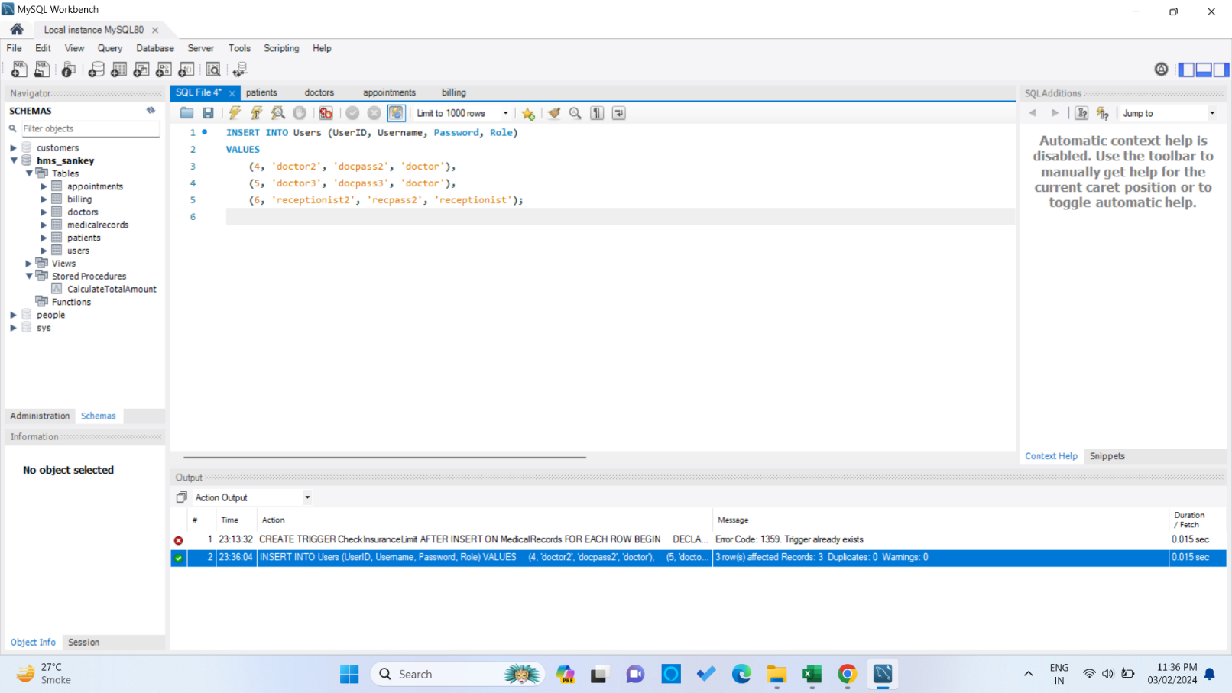Write necessary queries to register new user roles and personas
2. Write necessary queries to add to the list of diagnosis of the patient tagged by date.

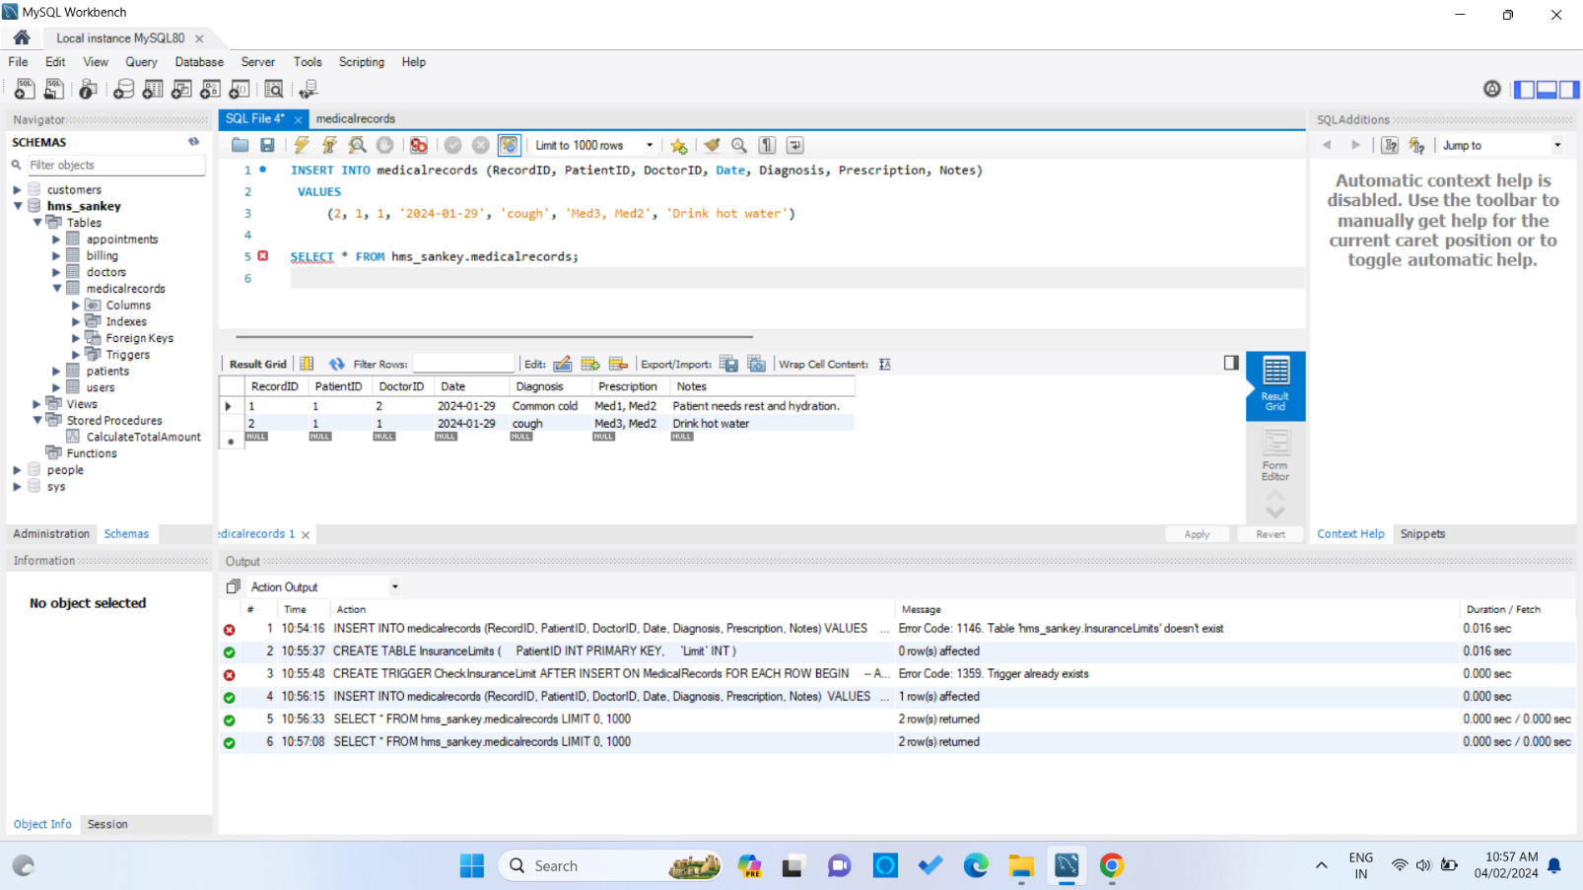

1. 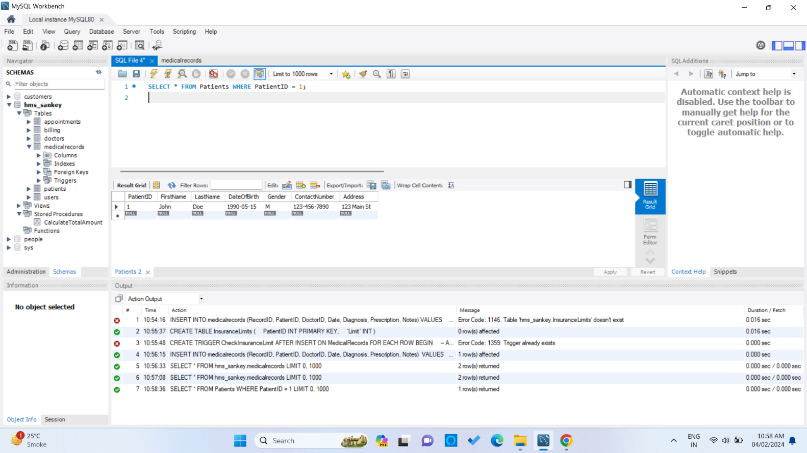Write necessary queries to fetch required details of a particular patient.
2. 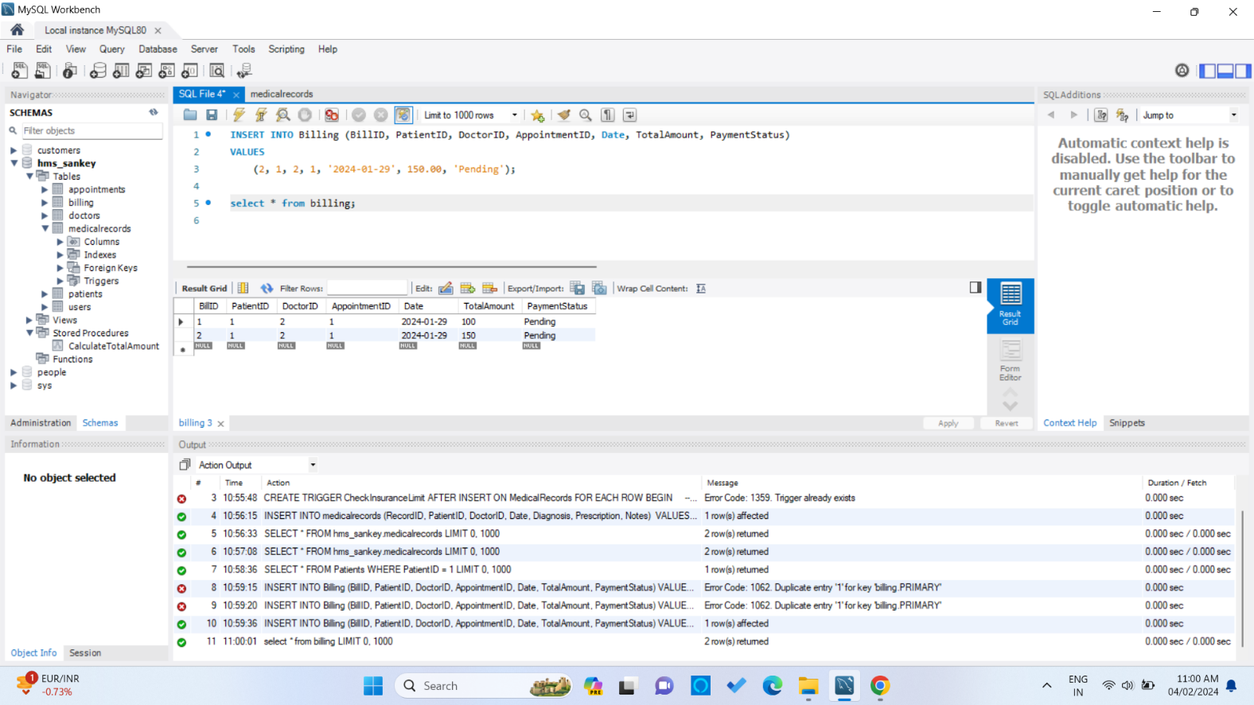Write necessary queries to prepare bill for the patient at the end of checkout.
3. 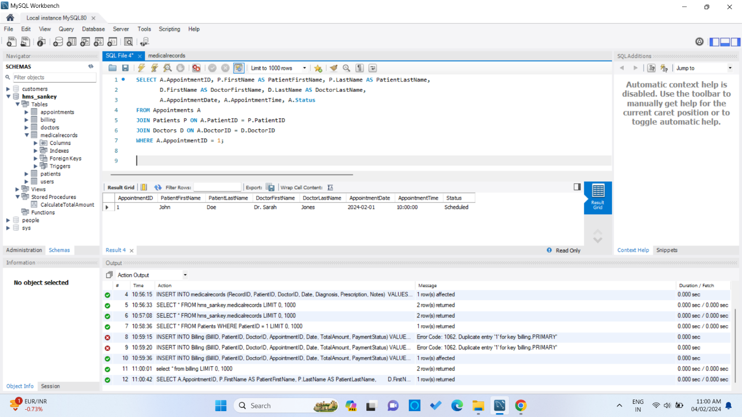Write necessary queries to fetch and show data from various related tables (Joins)
4. 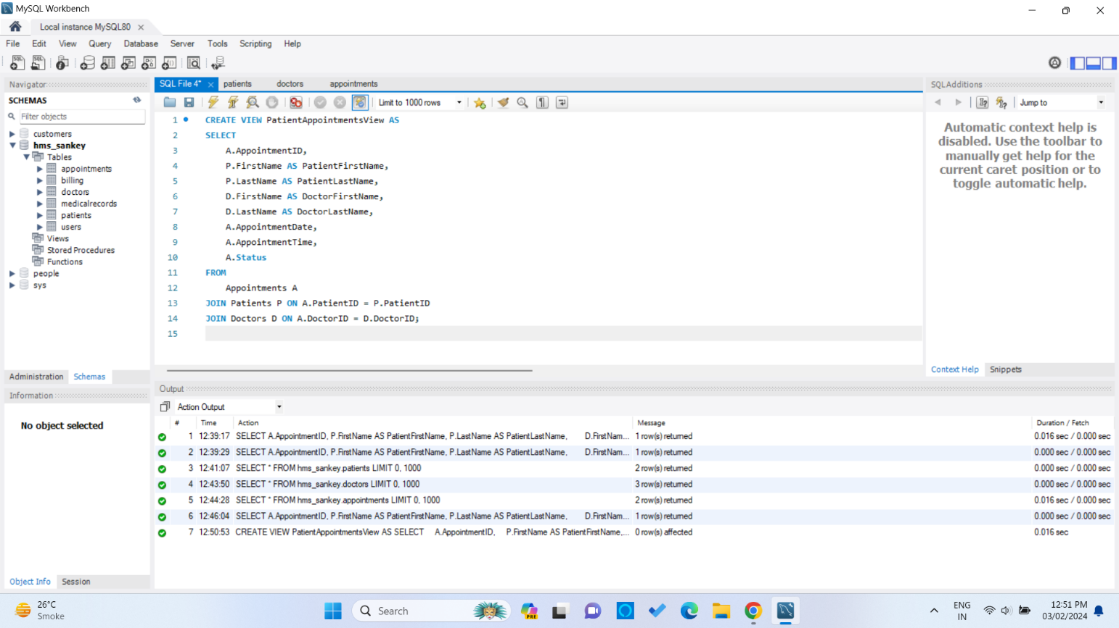Optimize repeated read operations using views/materialized views.
5. 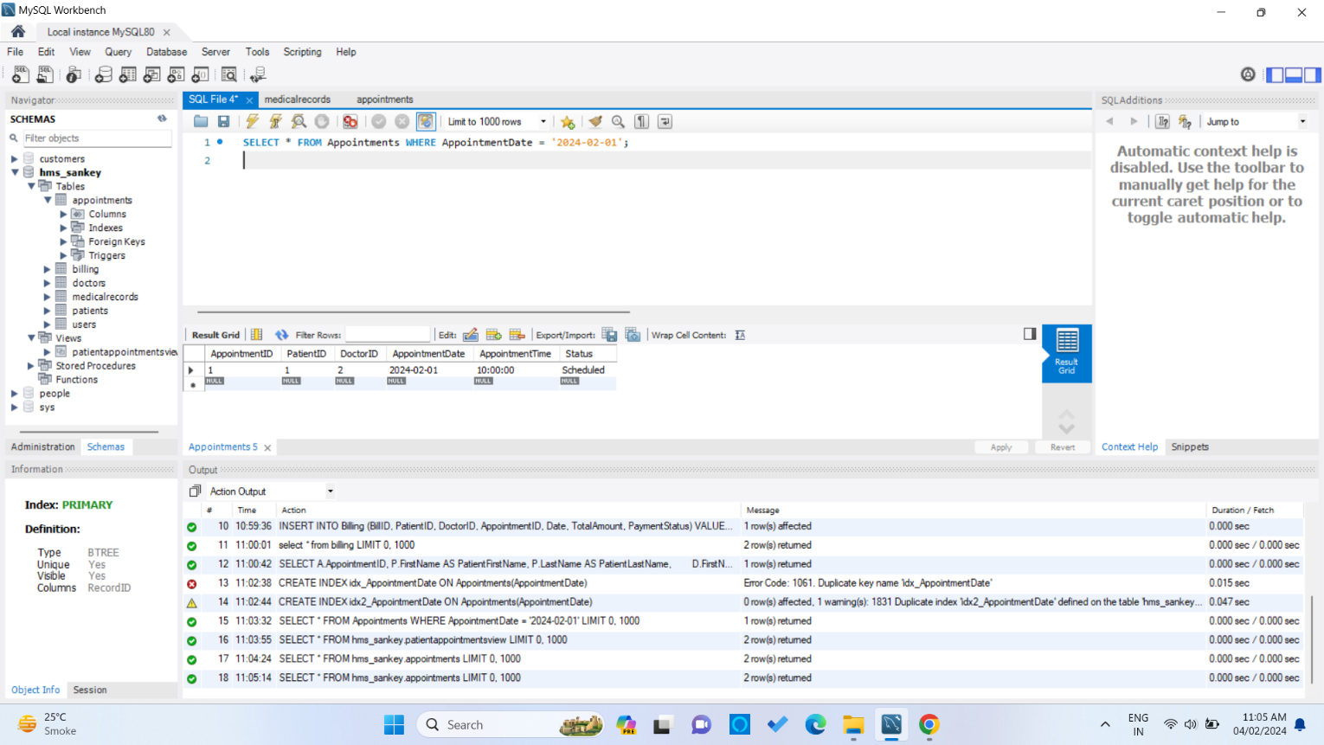Optimize read operations using indexing wherever required. (Create index on at least 1 table)
6. 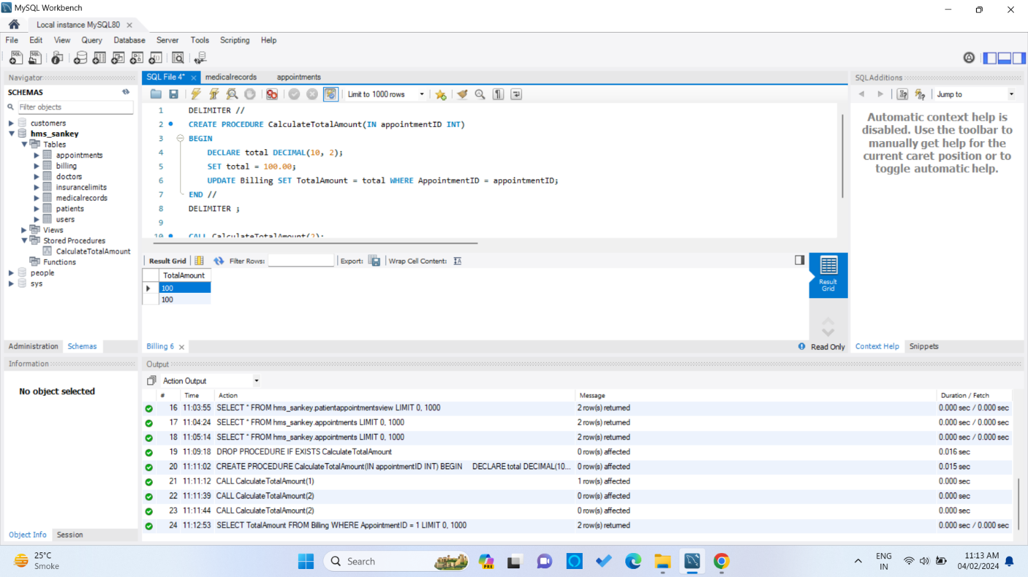Try optimizing bill generation using stored procedures.
7. 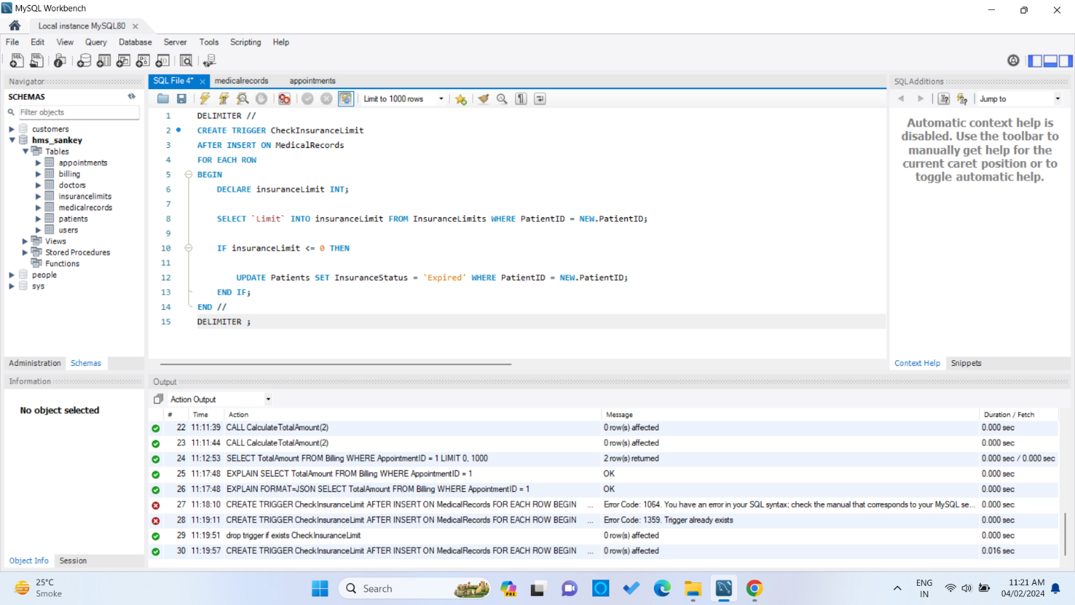Add necessary triggers to indicate when patients medical insurance limit has expired.